Postal Life Insurance

Department of Post

Software Requirements Specification (SRS)/ Functional Requirements Specification (FRS)
  - Single Sign-On (SSO)

INTERNAL APPROVAL FORM

Project Name: Single Sign-On
Version: 1.0
Submitted on:
 | Name | Date
Approved By:
Reviewed By:
Prepared By:

VERSION CONTROL LOG
Version | Date | Prepared By | Remarks
1

Table of Contents

1. Executive Summary 4
2. Project Scope 4
3. Business Requirements 4
4. Functional Requirements Specification 5
4.1 Authentication Flow 5
4.2 Login page 5
4.3 Forget/Reset Password 5
4.4 SSO Admin Console and Session Management 5
5. Appendices 6

1. Executive Summary
The purpose of this SRS document is to define the requirements for the Single Sign-On (SSO) module within the Insurance Management System (IMS) of India Post PLI.
This module will enable secure and seamless authentication for users across various IMS modules (Policy Admin, Claims, HR, Reports, etc.) using one unified login. It will ensure centralized user identity management, session control, and audit logging.

2. Project Scope
This module will:
- Provide centralized authentication for all IMS modules.
- Integrate with India Post’s existing identity provider (IdP) or Active Directory.
- Support role-based access control.
- Ensure secure session management and token-based authentication.
- Log all login/logout activities for audit purposes.

3. Business Requirements

Requirement ID | Requirements
FS_SSO_001 | Users should log in once and access all IMS modules without re-authentication.
FS_SSO_002 | SSO should integrate with India Post’s existing identity provider (e.g., LDAP, AD, or OAuth2).
FS_SSO_003 | Role-based access should be enforced post-authentication.
FS_SSO_004 | Session timeout and auto-logout should be configurable.
FS_SSO_005 | Login/logout activities should be logged for audit and compliance.
FS_SSO_006 | SSO should support multi-factor authentication (MFA) if enabled by the IdP.
FS_SSO_007 | SSO should work across web and mobile platforms.
FS_SSO_008 | Users should be redirected to their respective dashboards based on role and office hierarchy.
FS_SSO_009 | Admins should be able to revoke access centrally.
FS_SSO_010 | System should support token refresh and revocation.

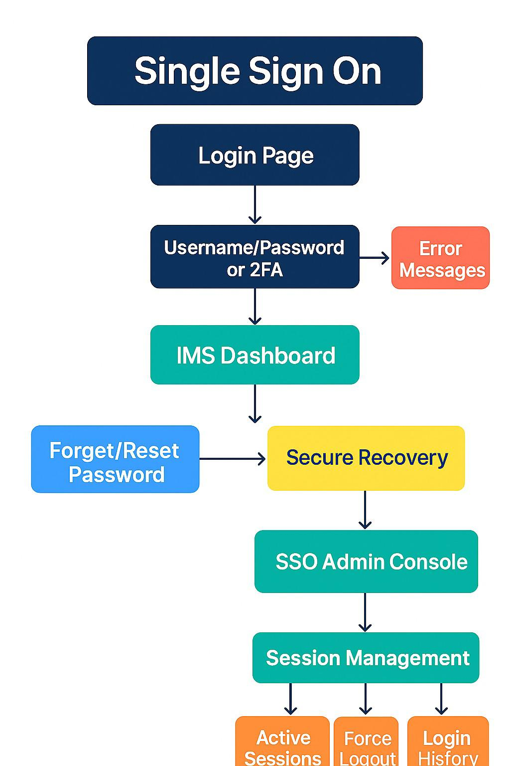

4. Functional Requirements Specification

4.1 Authentication Flow
Function | Description
Login | Authenticate user via centralized IdP
Token Generation | Generate secure access token post-authentication
Token Validation | Validate token for each module access
Role Mapping | Map user to roles and permissions
Session Management | Manage session lifecycle and timeout
Logout | Invalidate session and token
Audit Logging | Log login/logout and token activities
MFA Support | Trigger MFA if configured in IdP

4.2 Login page
User authentication entry point for IMS.
Features:
- Supports username/password or 2FA
- Error messages for invalid credentials
- Auto redirect to IMS dashboard upon success

4.3 Forget/Reset Password
Enables users to recover or reset their password securely.

4.4 SSO Admin Console and Session Management
Administrative management of SSO configuration. Track and manage active user sessions.
Fields:
- Active Sessions: List of currently logged-in users
- Force Logout: Button to terminate selected user session
- Login History: Table of login/logouts with timestamps
- Audit Log: Full trail of SSO activities

5. Appendices
The Following Documents attached below can be used.

